### **Lee’s elastic frame**

Lee’s frame along with its geometrical and material properties is shown in Fig. 1. The frame was modeled with twenty thin-walled two-node beam elements. For the loaded node two equilibrium paths are plotted, showing the relationship between load P and vertical and horizontal displacements.

L2

L1

L

L

21

19

17

15

13

11

9

7

5

3

1

*y*

*x*

# **General Data**

L = 120 cm

L1 = 96 cm

L2 = 24 cm

E = 720 t/cm2

ν = 0.3

2cm

3cm

Figure 1. Lee’s elastic frame

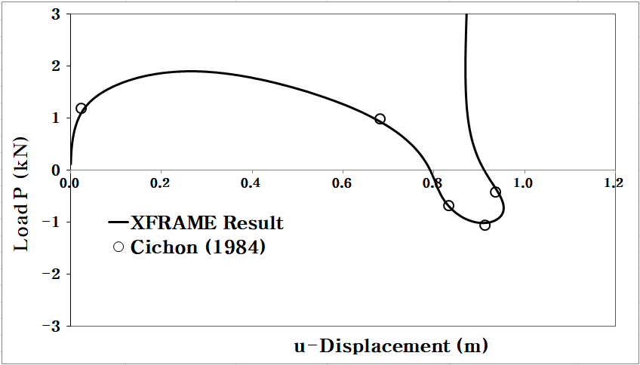

Figure 2Nonlinear load and X-displacement relationship of Lee’s frame

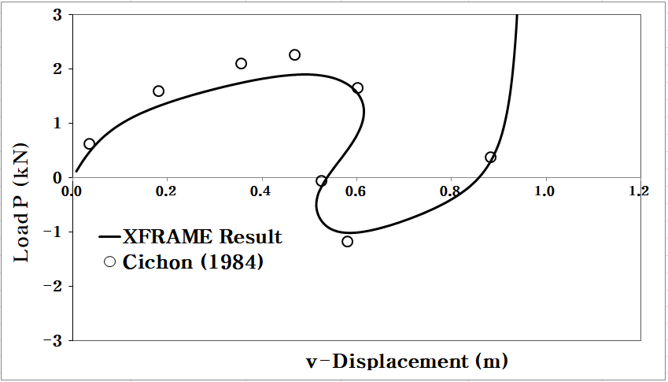

Figure 3 Nonlinear load and Y-displacement relationship of Lee’s frame